
INTERNSHIP REPORT APPROVAL FORM

July 1, 2019

With immense pleasure, this is to approve that the students of Sona College of Technology, Salem. i.,e

Thirukkumaran V(1516102147),
Faizan R(1516102035),
Aishwarya S(1516102002)
successfully completed their Project and Project Report on “Customer Recommendation System” under our guidance.
We are highly impressed with the work that they have done and commend them on their quick grasping skills. They have shown good intent to learn and have put the knowledge gained into application in the from of this project. We appreciate the hard work and commitment shown by them.
We, hereby approve that this document is completely checked and accepted by SmartBridge Technical Team. Its been an absolute pleasure to educate and mentor these students. We hope that this document will also serve as a Letter of Recommendation, to whomsover applied.

We wish them success in all future endeavors and a great career ahead.

GD Abhishek
AI Developer

Title: Customer Recommendation System

S.No | Table of Content | Page No
1 | 1.1 Introduction | 3
 | 1.2Objective of Research | 3
 | 1.3 Problem Statement | 3
2 | Review Of Literature | 4
 | 2.1 Data mining Techniques | 4
 | 2.2 Memory based collaborative filtering | 4
3 | Data Collection | 5
4 | Methodology | 5
 | 4.1 figures and Tables | 5
 | 4.2 Data Modeling | 8
5 | References | 8
6 | Conclusion | 8

- CUSTOMER RECOMMENDATION SYSTEM
1.1-Introduction:
Python is a popular programming language used for web development (server-side), software development, mathematics, system scripting. Python can be used on a server to create web applications and alongside software to create workflows. Python can be used to handle big data and perform complex mathematics. Python can be used for rapid prototyping, or for production-ready software development. Artificial intelligence (AI) is an area of computer science that emphasizes the creation of intelligent machines that work and react like humans. Some of the activities computers with artificial intelligence are designed for include Speech recognition, Learning, Planning, Problem solving.

1.2-Objective of Research:
Product recommendation system is one of the most successful and widespread
applications of deep learning in the business. Product or content recommendations to a
particular user preferences creates a positive effect on sales revenues and user experience.
There are several types of product recommendation systems, each based on different deep learning algorithm.Our algorithm recommends the customers to buy a product based on the user profile data and previously purchased data. It recommends automatically to the user.

1.3-Problem Statement:
In shopping malls, giving recommendation to the customer about the new products arrivals, information about the offers for the products based on the customer interest. In order to build a product recommendation system, the first thing that is needed is the data about user/customer personal details and their purchasing details. The system will ensure whether the customer already visit the shop or not. Using the web camera capturing and training the customer’s face features such as eyes, nose, and mouth. Using the trained image data, we can predict the customer already visited or not. If the customer is new to the shop, the model will add the new customer details to the existing dataset. Once we find the customer detail next getting the purchased details of the customer and analyzing the previous purchased details and let customer know the offers,discounts,new arrivals related to the previous purchasing products.

2. REVIEW OF LITERATURE

2.1 Data mining Techniques:
The data mining techniques include classification, clustering, association rules, regression analysis, sequence analysis, rule-based reasoning approach, genetic algorithms, decision trees, fuzzy logic, inductive learning systems, and statistical methods. Generally, no tool for data mining in customer segmentation is flawless. There are some uncertain drawbacks in it. For example, in terms of decision trees, too many instances lead to large decision trees which may decrease classification accuracy rate and do not clearly create the relationships which come from the training examples.
In terms of artificial neural networks, number of hidden neurons, number of hidden layers and training parameters need to be determined, and ANN has long training times in a large dataset especially. Moreover, ANN served as ‘‘black box” which leads to inconsistency of the outputs, is a trial-and-error process.

2.2 Memory-based collaborative filtering:
The CF algorithms are popular techniques for E-Systems. It involves the user-item database to predict which items users really like. According to every user who belongs to a group of people with similarity interests, we can find a group of people who share similar interests. By doing so, we can recommend the item to a user by it. In fact, it is neighborhood-based recommendation system and very prevalent.
The neighborhood-based CF algorithm uses the following steps. Firstly, calculate the similarity represented by W(i,j) which reflects correlation or distance between two uses or two items ,i and j. Secondly, predict the unknown ratings of the user or item on a certain item or user by aggregating the neighbors who are k most similar to get the top-N most frequent items as the recommendation, when the task is to generate a top-N recommendation result.

3. DATA COLLECTION
Our approach contain the two types of data. One data includes details such as their name, mobile number, address, face feature images. The second data is customer’s previously purchased details of the products. Data collection of Customer’s image is captured and products details are stored in the IBM cloud database.

4. METHODOLOGY

4.1Exploratory Data Analysis

4.1.1 Figures and Tables

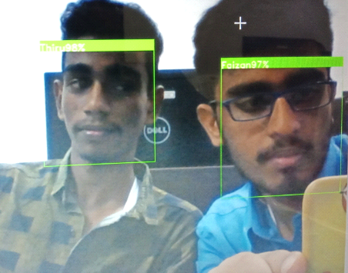

Fig 1.1 (Face Detection using SVM algorithm)

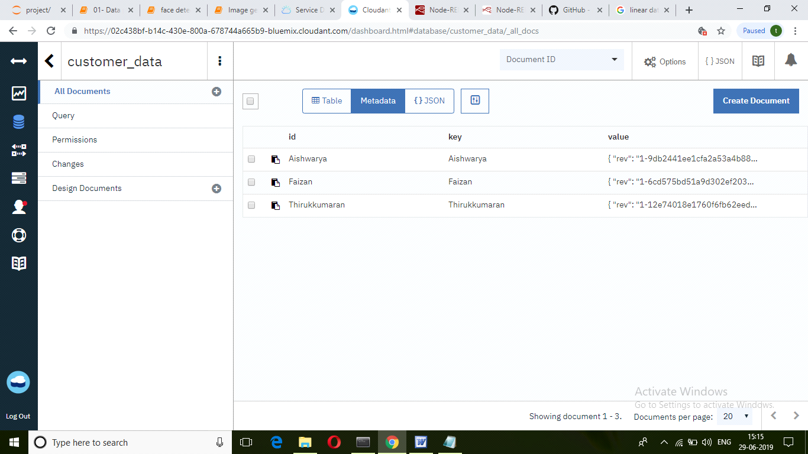

Fig 1.2 (Creating customer database)

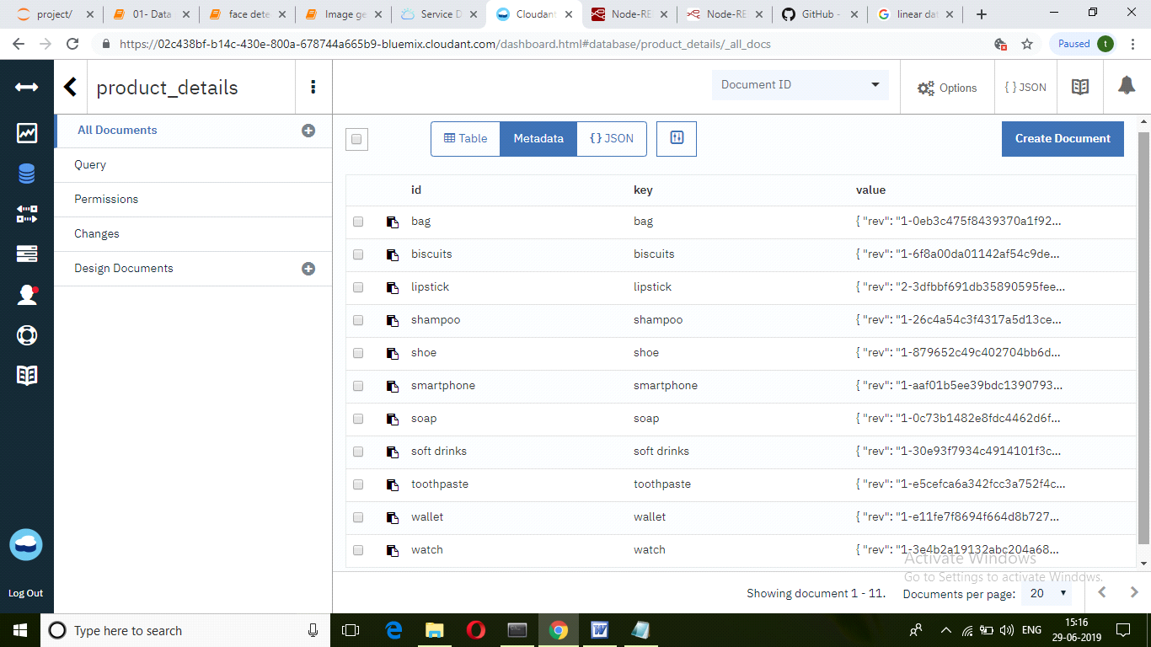

Fig 1.3 (Creating product database)

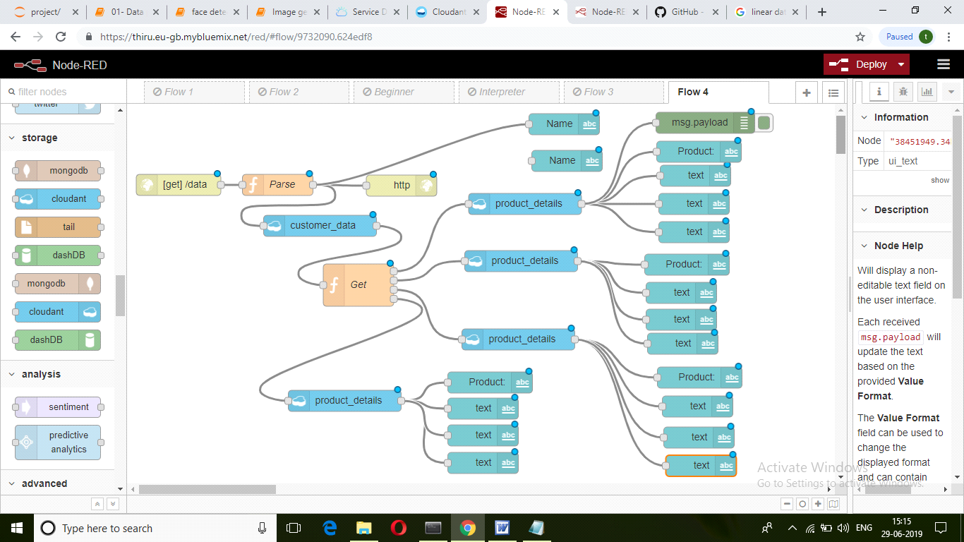

Fig 1.4 (Node Red connections)

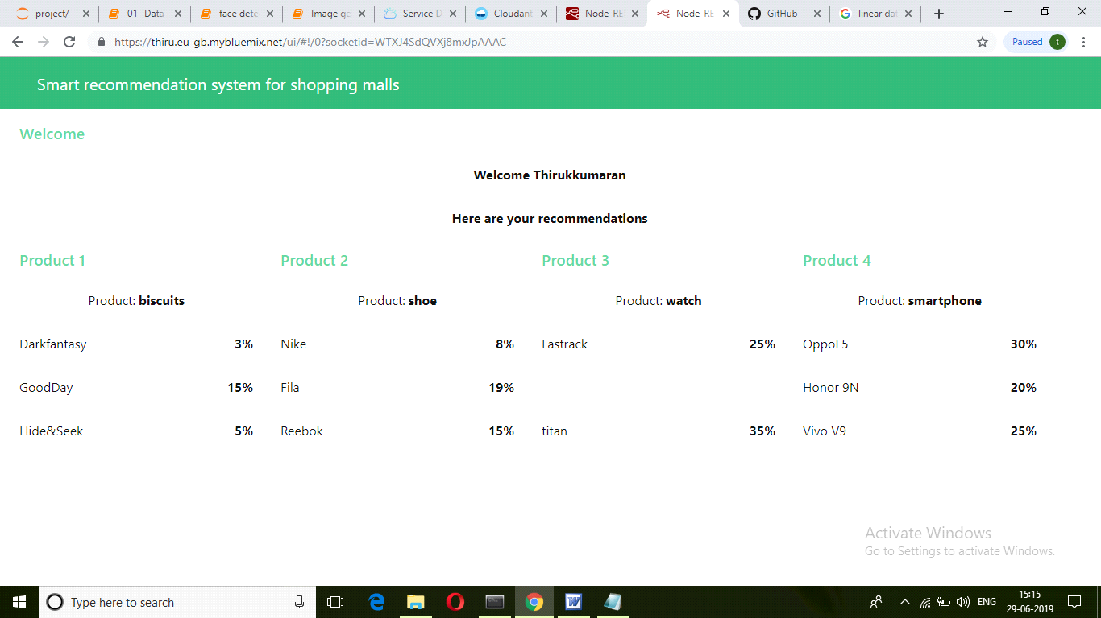

Fig 1.5 (User Interface)

4.2-Data Modeling

The major goal in our approach is collecting the image data. After collecting all the necessary data ,we trained them using suitable machine learning algorithm with good accuracy prediction (SVM algorithm).Nearly 1500 images of individual customer photos is trained using SVM algorithm for generating .pickle file. The file has all the facial features of the customer and are ready to predict the customer. Once the customer is identified, the value is sent to the IBM cloud and using the database stored in the cloud will fetch the details of previously purchased products and recommends the products that are in offer.

5. REFERENCES

https://www.netguru.com/blog/how-to-build-a-product-recommendation-system.-machine-learning-solutions

http://www.ijrbsm.org/pdf/v2-i11/5.pdf

https://towardsdatascience.com/recommender-systems-in-practice-cef9033bb23a

https://arxiv.org/pdf/1708.07289.pdf

6. CONCLUSION

Product recommendation to a particular user preferences creates a positive effect on sales revenues and user experience. An idea towards the growth of Technology

